4th July 2023

To Members of the Recreation, Parks & Property Committee

Cllrs Brooke (Ex Officio), Allen, Arnold, Kelly, Mills, Oldrieve & Simmons.

Cc: All other members of the Council for information

Dear Councillor,

You are hereby summoned to attend a meeting of the Recreation, Parks & Property (RP&P) Committee which will be held at the Riverside Community Centre on Monday 10th July 2023 at 7.00pm for the purpose of transacting the business as set out on the agenda below.

AGENDA

RP&P.23/32 Apologies for Absence:
To receive and consider for acceptance, apologies for inability to attend.

RP&P.23/33 Declarations of Interest and Requests for Dispensations
To declare any disclosable pecuniary interests or any other interest which members may have in the following agenda items and consider any dispensation requests.

**Public Participation:
We welcome the public to attend meetings and invite comments or questions regarding any of the agenda items. The Committee, at the Chairman’s discretion, sets aside a short period of time for this at the commencement of the meeting.

RP&P.23/34 Minutes:
i) To agree as a correct record and approve the minutes of the meeting of 30th May 2023 (*copy enclosed).
ii) To receive any update(s) on actions/items from the previous meeting.

RP&P.23/35 Standing Item – Climate and Ecology Emergency:
To note the Council Declaration and to embed the climate and ecology emergency declaration across all Council services, activities, plans and other relevant work, considering the environmental impact of decisions, ensuring a fully integrated approach to mitigating the impact of climate change.

RP&P.23/36 Friends of Mill Marsh Park (FoMMP):
To receive and note minutes of the FoMMP meeting held on 06.07.23 (*copy to be circulated).

RP&P.23/37 Redevelopment of Mill Marsh Park Play Area – Contractor Appointment
To receive a report and to consider the recommendations within (*copy to be circulated).

RP&P.23/38 Hedgehogs R Us Highway Project
To consider and agree action as appropriate. Item referred by Full Council following the resolution to decline the request from ‘Hedgehogs R Us Highway Project’.

RP&P.23/39 Riverside Community Centre – Public Toilets – Redecoration
To consider and approve a quotation for the internal repainting of the public toilets at the Riverside Community Centre:

Quotation A £785.00
Quotation B £1,450.00
Quotation C £1,295.84

RP&P.23/40 Matters brought forward by the Town Clerk & Councillors: (for information)

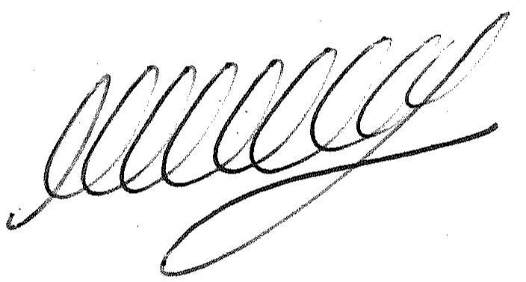

SIGNED ………………………………………………….. DATE: 4th July 2023

M WELLS - TOWN CLERK

*Copies of correspondence circulated to Councillors with this agenda, which will be considered at the meeting.

