
30th April 2025

Under ‘The Openness of Local Government Bodies Regulations 2014’ this meeting has been advertised as a public meeting and as such could be filmed or recorded by broadcasters, the media or members of the public.

* The Town Council invites members of the public to ask questions or raise issues relevant to the work of the Council. The overall time available for this session is restricted to 15 minutes unless the Chair decides otherwise. Please note: questions to be submitted in writing, to arrive via email at the Council Office by 12 noon on the day of this meeting.

All members of the public are invited to join Councillors for refreshments from 6.30pm.

Dear Councillor,

You are hereby summoned to attend the Annual Meeting of Bovey Tracey Town Council on Wednesday 7th May 2025 at 7.00pm at the Riverside Community Centre for the purpose of transacting the business as set out on the agenda below.

AGENDA

AM.25/01 Election of the Town Mayor & Chairperson for 2025/26:
i) The Retiring Town Mayor will seek nominations and elect the Town Mayor for the ensuing civic year.
ii) The new Town Mayor to make the Declaration of Acceptance of Office and a short speech.

AM.25/02 Election of Deputy Town Mayor for 2025/26:
i) To seek nominations and elect the Deputy Town Mayor for the ensuing civic year.
ii) The new Deputy Town Mayor to make the Declaration of Acceptance of Office and a short speech.

AM.25/03 Apologies for absence
To receive apologies for inability to attend.

AM.25/04 Declarations of Interest and Requests for Dispensations
To declare any disclosable pecuniary interests or any other interest which members may have in the following agenda items and consider any dispensation requests.

AM.25/05 Minutes
i) To receive and resolve as a correct record the minutes of the Full Council meeting held on 17.03.25 (*copy enclosed).
ii) To receive an update on any matters arising from the previous Full Council meeting (if any).

AM.25/06 Standing Item – Climate and Ecology Emergencies:
To note the Council Declaration and to embed the Climate and Ecology Emergency Declaration across all Council services, activities, plans and other relevant work, considering the environmental impact of decisions, ensuring a fully integrated approach to mitigating the impact of climate change.

The meeting will go out of session

AM.25/07 Reports from Key Bodies on Parish related matters:
To receive the reports (if any) from key bodies including:
i) Churches Together
ii) Police
iii) County, District and Town Councillors
iv) Town Mayors Interests (*copy enclosed)
v) Other outside bodies

AM.25/08 Questions and Statements by the Public
The Town Mayor will invite Members of the Public to give their views and question the Town Council on issues on this agenda, or raise issues for future consideration (maximum 3 minutes per person).

The Town Mayor will make a short presentation to the newly appointed Honorary Representative of the Lord of the Manor for Bovey Tracey.

The meeting will go back into session

AM.25/09 Business Raised by the Public:
To resolve to refer any business raised by the public in public discussion and any other matters or items of information from Councillors, to the appropriate Committee or to resolve to agree on any other action.

AM.25/10 Election of Committees/Sub Committee:
To consider and approve nominations for the Town Council’s Committees for 2025/26:

Standing Committees | Number of Members
Recreation, Parks & Property Committee | 7 Councillors (incl. Ex Officio)
Finance, Resources & General Purposes Committee | 7 Councillors (incl. Ex Officio)
Planning & Environment Committee | 7 Councillors (incl. Ex Officio)
Personnel Committee | 3 Councillors (plus Ex Officio)
Appeals Committee | 3 Committee Chairs plus Town Mayor

AM.25/11 Representatives on Outside Bodies:
To receive and approve nominations for Town Council representatives on outside bodies:

Outside Body | Number of Members
Devon Association of Local Councils (DALC) | 1
Bovey Tracey Heritage Trust | 2
Bovey Tracey Information Centre CiC | 1
Police & Crime Commissioner Council Advocate Scheme | 1
Bovey Tracey Youth Action | 1
Business for Bovey | 1
Bovey Tracey/Le Molay-Littry Twinning Association | 1
Friends of Mill Marsh Park | 1
Heathfield Action Team | 2
Bovey Tracey Fairtrade (+ Serving Mayor as President) | 2
Heathfield Rail Link Project | 1
Bovey Paradiso Arts | 1
East Dartmoor National Nature Reserve Advisory Group | 1

AM.25/12 Recreation, Parks & Property Committee (RP&P) Committee:
To receive and adopt the minutes of the meeting held on 31.03.25 (*draft copy enclosed).

AM.25/13 Finance, Resources & General Purposes (FR&GP) Committee:
i) To receive and adopt the minutes of the meeting held on 14.04.25 (*draft copy enclosed).
ii) To receive a recommendation to re-adopt the following reviewed policies:
- Information & Data Protection (*copy to be circulated)
- Data Breach (*copy to be circulated)
- Subject Access Request (*copy to be circulated)

AM.25/14 Planning & Environment Committee:
To receive and adopt the minutes of the meetings held on 31.03.25 (*copy enclosed) and 14.04.25 (*draft copy enclosed).

AM.25/15 Personnel Committee:
To receive and adopt the minutes of the meetings held on 18.03.25 (*copy enclosed) and 10.04.25 (*draft copy enclosed).

AM.25/16 Annual Governance & Accountability Return - 2024/25:
i) To receive and note the Annual Internal Audit Report (*copy enclosed).

ii) To approve the Annual Governance Statement (section 1 of the annual return) (*copy enclosed) and agree that the Chairperson and Town Clerk sign the document.

iii) To approve the accounting statements (section 2 of the annual return) (*copy enclosed) together with an explanation of variance of 15% and above (*copy enclosed) and a statement of income & expenditure relating to box 7 & 8 of the return (*copy enclosed) and agree that the Chairperson signs the document(s).

iv) To approve the annual financial statement for year ended 31st March 2025 as an accurate reflection of the financial position of the Council and its income and expenditure (*copy enclosed) and agree that the Chairperson signs the document.

v) To approve the year end bank reconciliation for 2024/25 (*copy enclosed).

vi) To approve the dates of 3rd June – 14th July 2025 for the Period for the Exercise of Public Rights with the announcement (Date of Announcement of notice to be published on the Councils website advising public rights and publication of unaudited Annual Governance & Accountability Return) being posted on 9th May (*copy enclosed).

vii) To review and approve the current Asset Register (*copy enclosed).

AM.25/17 Standing Orders:
To review and re-adopt the Standing Orders (*copy enclosed).

AM.25/18 Committee Terms of Reference:
To review and re-adopt Committee Terms of Reference (*copy enclosed).

AM.25/19 Financial Regulations:
To review and re-adopt Financial Regulations (*copy enclosed).

AM.25/20 Meeting Schedule 2025/26:
To consider adopting the draft meetings schedule (*copy enclosed) for all Standing Committee meetings for the period from 8th May 2025.

AM.25/21 Councillor Training
To receive and note current training opportunities (*copy enclosed) which can be booked via the Town Clerk.

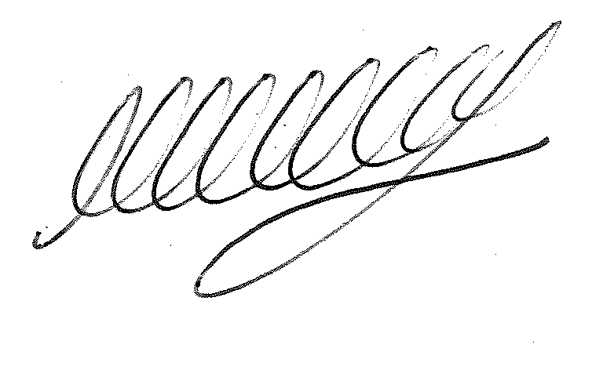

SIGNED…………………………………………………… DATE 30th April 2025

M WELLS - TOWN CLERK

*Copies of any correspondence circulated to Councillors with this agenda, which will be considered at this meeting.

Reminder for Members:

- You must declare the nature of any disclosable pecuniary interests (under the Localism Act 2011, this means the interests of your spouse, or civil partner, a person with whom you are living with as husband and wife or a person with whom you are living as if you are civil partners). You must also disclose any personal interest.

- You must disclose your interest in an item whenever it becomes apparent that you have an interest in the business being considered.

- Make sure you say what your interest is, as this has to be included in the minutes. (For example, ‘I have a disclosable pecuniary interest because this planning application is made by my husband’s employer’).

- If your interest is a disclosable pecuniary interest, you cannot participate in the discussion, cannot vote and must leave the room unless you have obtained a dispensation from the Clerk.

