12th September 2023

Under ‘The Openness of Local Government Bodies Regulations 2014’ this meeting has been advertised as a public meeting and as such could be filmed or recorded by broadcasters, the media or members of the public.

* The Town Council invites members of the public to ask questions or raise issues relevant to the work of the Council. The overall time available for this session is restricted to 15 minutes unless the Chair decides otherwise. Please note: questions to be submitted in writing, to arrive via email at the Council Office by 12 noon on the day of this meeting.

Dear Councillor,

You are hereby summoned to attend a meeting of Bovey Tracey Town Council on Monday 18th September 2023 at 7.00pm at the Riverside Community Centre for the purpose of transacting the business as set out on the agenda below.

AGENDA

FC.23/44 Apologies for absence
To receive apologies for inability to attend.

FC.23/45 Declarations of Interest and Requests for Dispensations
To declare any disclosable pecuniary interests or any other interest which members may have in the following agenda items and consider any dispensation requests.

FC.23/46 Minutes
i) To receive and resolve as a correct record the minutes of the Full Council meeting held on 26.06.23 (*copy enclosed).
ii) To receive an update on any matters arising from the previous Annual Council meeting (if any).

FC.23/47 Standing Item – Climate and Ecology Emergency:
To note the Council Declaration and to embed the Climate and Ecology Emergency Declaration across all Council services, activities, plans and other relevant work, considering the environmental impact of decisions, ensuring a fully integrated approach to mitigating the impact of climate change.

The meeting will go out of session

FC.23/48 Reports from Key Bodies on Parish related matters:
To receive the reports (if any) from key bodies including:
i) Chaplain to the Council
ii) Police (*copy enclosed)
iii) County (Cllr Gribble), District (Cllrs Morgan, Smith (*copy enclosed) and Webster) and Town Councillors (all)
iv) Town Mayors Interests (*copy enclosed)
v) Other outside bodies

FC.23/49 Questions and Statements by the Public
The Town Mayor will invite Members of the Public to give their views and question the Town Council on issues on this agenda, or raise issues for future consideration (maximum 3 minutes per person).

The Town Mayor will make a certificate presentation for Fairtrade Town Status.

The meeting will go back into session

FC.23/50 Business Raised by the Public:
To resolve to refer any business raised by the public in public discussion and any other matters or items of information from Councillors, to the appropriate Committee or to resolve to agree on any other action.

FC.23/51 Recreation, Parks & Property Committee (RP&P) Committee:
To receive and adopt the minutes of the meeting held on 10.07.23 (*draft copy enclosed).

FC.23/52 Finance, Resources & General Purposes (FR&GP) Committee:
i) To receive and adopt the minutes of the meeting held on 04.09.23 (*draft copy enclosed).
ii) To consider a recommendation to adopt a CiL Groups Policy (*copy enclosed)

FC.23/53 Planning & Environment Committee:
i) To receive and adopt the minutes of the meetings held on 10.07.23 and 04.09.23 (*draft copy enclosed).
ii) To consider a recommendation to re-adopt the Environmental Policy (*copy enclosed)

FC.23/54 Personnel Committee
To consider a recommendation to adopt a Safeguarding Policy (*copy enclosed).

FC.23/55 Committee Membership:
To review and agree revised membership following the recent co-option of Heathfield Councillors.

FC.23/56 Bovey Tracey Fairtrade:
To receive and consider a report on behalf of Cllr Oldrieve and a motion to support the ethos of Fairtrade and the Bovey Tracey Fairtrade Group (*copy enclosed)

FC.23/57 Asset Register:
To review and approve the current Asset Register (*copy enclosed)

FC.23/58 Financial & Non-Financial Internal Controls:
To review and approve the current Financial and Non-Financial Internal Controls (*copy enclosed)

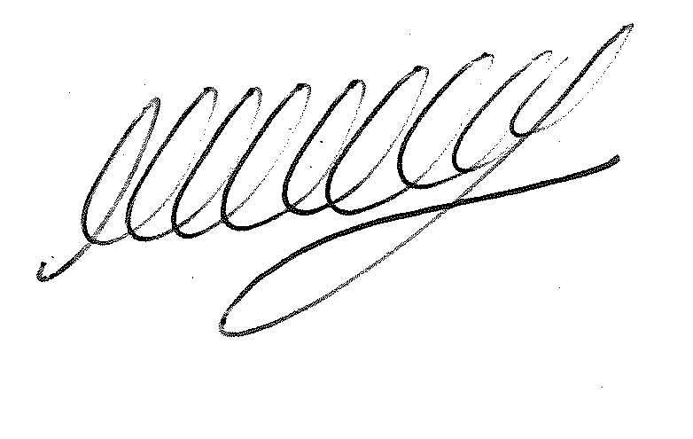

SIGNED…………………………………………………… DATE 12th September 2023

M WELLS
TOWN CLERK

*Copies of any correspondence circulated to Councillors with this agenda, which will be considered at this meeting.

Reminder for Members:

- You must declare the nature of any disclosable pecuniary interests (under the Localism Act 2011, this means the interests of your spouse, or civil partner, a person with whom you are living with as husband and wife or a person with whom you are living as if you are civil partners). You must also disclose any personal interest.

- You must disclose your interest in an item whenever it becomes apparent that you have an interest in the business being considered.

- Make sure you say what your interest is, as this has to be included in the minutes. (For example, ‘I have a disclosable pecuniary interest because this planning application is made by my husband’s employer’).

- If your interest is a disclosable pecuniary interest, you cannot participate in the discussion, cannot vote and must leave the room unless you have obtained a dispensation from the Clerk.

