

5th December 2023

**To Members of the Recreation, Parks & Property Committee**

Cllrs Brooke (Ex Officio), Arnold, Kelly, Mills-Brown, Oldrieve, Robillard Webb & Simmons.

Cc: All other members of the Council for information

Dear Councillor,

You are hereby summoned to attend a meeting of the **Recreation, Parks & Property (RP&P) Committee** which will be held at the **Riverside Community Centre** on **Monday 11th December 2023 at 7.00pm** for the purpose of transacting the business as set out on the agenda below.

**AGENDA**

**RP&P.23/55 Apologies for Absence**:

To **receive** and **consider** for acceptance, apologies for inability to attend.

**RP&P.23/56 Declarations of Interest and Requests for Dispensations**

To **declare** any disclosable pecuniary interests or any other interest which members may have in the following agenda items and **consider** any dispensation requests.

**\*\*Public Participation:**

*We welcome the public to attend meetings and invite comments or questions regarding any of the agenda items. The Committee, at the Chairman’s discretion, sets aside a short period of time for this at the commencement of the meeting.*

**RP&P.23/57** **Minutes**:

i) To **agree** as a correct record and approve the minutes of the meeting of 16th October 2023 *(*[*\*copy enclosed*](https://www.dropbox.com/scl/fi/8jr9tg8kc28idgo5nqjnq/11.12.23-DRAFT-RP-P-Minutes-of-Meeting-held-on-16.10.23-v2.docx?rlkey=2lovdfeflztyv7tnxqfq1078d&dl=0)*).*

ii) To **receive** any update(s) on actions/items from the previous meeting.

**RP&P.23/58 Standing Item – Climate and Ecology Emergency:**

To **note** the Council Declaration and to embed the climate and ecology emergency declaration across all Council services, activities, plans and other relevant work, considering the environmental impact of decisions, ensuring a fully integrated approach to mitigating the impact of climate change.

**RP&P.23/59 Friends of Mill Marsh Park (FoMMP):**

To **receive** and **note** a progress update on behalf of the FoMMP group ([*\*copy enclosed*](https://www.dropbox.com/scl/fi/ti4twv4vi4dc1ityo4y2o/11.12.23-Friends-of-Mill-Marsh-Park-Update-November-2023.docx?rlkey=re7nuniry090zjkzkk2lmrxjj&dl=0)).

**RP&P.23/60 Recreation Ground - Users Meeting**

To **receive** and **note** minutes of the Recreation Ground Users meeting held on 23.11.23 ([*\*copy enclosed*](https://www.dropbox.com/scl/fi/9i3si4cdu8kh1zfzimwwf/11.12.23-Recreation-Ground-Users-Meeting-23-11-23-Minutes.doc?rlkey=6aq6100j38gafl0nxdtos9wjd&dl=0)).

**RP&P.23/61 Riverside Community Centre – Feasibility Proposals**

To **receive** and **consider** DRAFT feasibility plans in principle which if deemed appropriate will then require further costings ([*\*copy enclosed*](https://www.dropbox.com/scl/fi/3ddfk0n8vifbmfrkqwf06/11.12.23-Riverside-CC-Feasibility-Layout-Design.pdf?rlkey=xdsj7q4q813ekz41qt8fylyod&dl=0)).

**RP&P.23/62 Litter Collections – Mill Marsh Park**

To **receive** a deferred item raised at Full Council about litter collections, waste and recycling facilities in Mill Marsh Park and to **consider** how the current service can be enhanced.

**RP&P.23/63 Open Space Risk Assessments**

To **review** and **approve** current assessments or to **consider** any other action as appropriate;

1. Cemetery ([*\*copy enclosed*](https://www.dropbox.com/scl/fi/ls3w5llzzxbo4m2dhha0u/11.12.23-Cemetery-GRA-02-2023.doc?rlkey=9zgymrtv16x4lrtknp3nz7wr5&dl=0))
2. Bullands Field ([*\*copy enclosed*](https://www.dropbox.com/scl/fi/qspqkj9pguilinlzwy3g8/11.12.23-Bullands-Field-GRA-02-2023.doc?rlkey=5mk0bt8rok9xtm31jkr9k5iqs&dl=0))
3. Heathfield Youth Cabins Area ([*\*copy enclosed*](https://www.dropbox.com/scl/fi/mt78yp9nz5m1xnnshdp1d/11.12.23-Heathfield-Youth-Cabins-Area-GRA-02-2023.doc?rlkey=a2rs9pb7mmiszmfz8gs67wr6j&dl=0))
4. Allotments ([*\*copy enclosed*](https://www.dropbox.com/scl/fi/v0ahtz2l2u78b0sc8krzc/11.12.23-Allotments-GRA-02-2023.doc?rlkey=wiwpcg8z5614l2imej7h481h0&dl=0))
5. Recreation Ground ([*\*copy enclosed*](https://www.dropbox.com/scl/fi/5awfum38mquidjxunp0xx/11.12.23-The-Recreation-Ground-GRA-02-2023.doc?rlkey=7i1xpl4tvh0m8dl5s8joyf2fl&dl=0))
6. Mill Marsh Park ([*\*copy enclosed*](https://www.dropbox.com/scl/fi/inpub7b3t4wz5b2glipre/11.12.23-Mill-Marsh-GRA-02-2023.doc?rlkey=s17n5tc7smq0q4874vx9zlh0y&dl=0))
7. Rendells Meadow ([*\*copy enclosed*](https://www.dropbox.com/scl/fi/s50flfjo7fxrooj9g26vo/11.12.23-Rendells-Meadow-GA-2023.docx?rlkey=xu1sw561af4pqjefax1c6hdkl&dl=0))

**RP&P.23/64** **Matters brought forward by the Town Clerk & Councillors**: (*for information)*

1. Prince Rupert Way Play Area redevelopment (Heathfield ward members)
2. Hedgehog Project (Cllr Simmons)

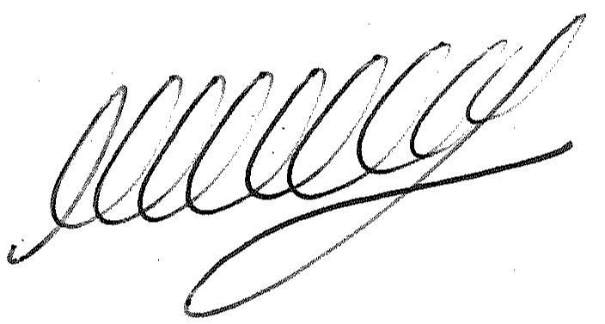

**SIGNED ………………………………………………….. DATE: 5th December 2023**

**M WELLS - TOWN CLERK**

***\*Copies of correspondence circulated to Councillors with this agenda, which will be considered at the meeting.***