

5th December 2023

**To: Members of the Planning & Environment Committee**

Cllrs Brooke (Ex Officio), Arnold, Evans, Kelly, Kennedy, Simmons, West.

Cc: All other members of the Council for information.

Dear Councillor,

You are hereby summoned to attend a meeting of the **Planning & Environment Committee** whichwill be held at the **Riverside Community Centre** on **Monday 11th December 2023** at **6:15pm** for the purpose of transacting the business as set out on the agenda below.

**AGENDA**

**PL.23/135 Apologies for absence**:

To **receive** and **consider** for acceptance, apologies for inability to attend.

**PL.23/136 Declarations of Interest and Requests for Dispensations**

To **declare** any disclosable pecuniary interests or any other interest which members may have in the following agenda items and **consider** any dispensation requests.

**\*\*Public Participation:**

*We welcome the public to attend meetings and invite comments or questions regarding any of the agenda items. The Committee, at the Chair’s discretion, sets aside a period of time for this at the commencement of the meeting.*

**PL.23/137 Minutes:**

i) To **agree** as a correct record and **approve** the minutes of the meeting of 27th November 2023 *(*[*\*copy enclosed*](https://www.dropbox.com/scl/fi/hejcscg64v5o0w0w09w41/11.12.23-DRAFT-Planning-and-Environment-Committee-Minutes-of-27.11.23.docx?rlkey=jdacowib97x60840vn7qu4h46&dl=0)*).*

ii) To **receive** any update(s) on actions/items from the previous meeting.

**PL.23/138****Standing Item – Climate and Ecology Emergency:**

To **note** the Council Declaration and to embed the climate and ecology emergency declaration across all Council services, activities, plans and other relevant work, considering the environmental impact of decisions, ensuring a fully integrated approach to mitigating the impact of climate change.

**PL.23/139 Consideration of Planning Applications**:

TDC Applications listed to 24.11.23:

1. **19/02541/MAJ** Construction of industrial building (for manufacturing, administration and support space), access and associated parking; Land at Heathlands, Old Newton Road, Bovey Tracey (Observations due: 12.12.23).
2. **23/01962/FUL** Change of Use of outbuilding from ancillary residential use to a holiday let; 10 Town Hall Place, Bovey Tracey (Observations due: 15.12.23).

DNPA Applications listed to 24.11.23:

None.

TDC Applications listed to 01.12.23**:**

1. **23/01995/FUL** Change of Use from Residential Institution (Class C2) to 15 Holiday units (including 8 caravan units); Tracey House Retirement Home, Bovey Tracey (Observations due: 27.12.23).

**PL.23/140** **Applications Delegated to the Town Clerk (to note):**

1. **23/01724/TPO** To dismantle two smaller Lawson Cypress down to ground level and the dead stem behind using arb approved techniques; Indio House, Newton Road, Bovey Tracey (Observations: Refer to TDC Arboricultural Officer).

**PL.23/141** **Planning Decisions**:

1. **Approvals:**   
   TDC:

**i) 22/01194/MAJ** Hybrid planning application for full planning permission for Class E foodstore with associated parking, servicing and landscaping and outline planning permission (with all matters except access reserved) for Class E(g)/B2/B8 employment uses (revised description 05.12.22); Land West of Monks Way and North of Marriott Wat, Bovey Tracey (Observations: No objection, subject to: i) confirmation that the Delivery Management Plan will control access/large delivery vehicles as appropriate to alleviate DCC Highways concerns, and ii) noise levels to be kept to a minimum and limited to appropriate times only so as not to cause annoyance to neighbouring residents. Furthermore, the following actions should be considered: i) With the provision of only 10 cycle places vs 100 car spaces, with accessibility for local people to a cheap store then consideration should be given to working with stagecoach to alter the bus route and ensure a bus stop is created at/nearby the supermarket itself to really promote sustainable travel. ii) In line with the Town Council's Climate Emergency Declaration and our efforts to increase trees in the area as part of carbon sequestration, we would request that the applicant plants at least 15 trees for 3 it will remove/part remove (noting that trees take 10 years to reach mature levels of carbon sequestration hence the need to plant 5 x that removed). iii) In accordance with the emerging Neighbourhood Development Plan, the development should not contravene Policy BPNP LE2 Tranquillity and Dark Skies (e.g. development should not introduce or increase light pollution). iv) In accordance with the emerging Neighbourhood Development Plan, the development should plant wildflower verges and maximise hedgerow additions where possible in support of Project 4 (to develop wildflower-rich verges to encourage pollinators and support a wider range of species) to improve biodiversity, particularly insect populations, especially if it can provide a wildlife corridor through to the neighbouring ponds).

**ii) 23/01964/TPO** T1 Oak – remove 3 lowest primary branches; Acorns, Old Newton Road, Bovey Tracey (Observations: Referred to TDC Arboricultural Officer).

**iii) 23/01106/REM** Approval of details for a dwelling pursuant to planning permission 17/01821/MAJ (approval sought for appearance, landscaping, layout and scale); Self build plot 06, Marriott Way, Bovey Tracey (Observations: No objection. The applicantwas commended for promoting sustainability in accordance with section 4.8 of the Bovey Parish Neighbourhood Development Plan).

**iv) 23/01165/REM** Approval of details for a dwelling pursuant to planning permission 17/01821/MAJ (approval sought for appearance, landscaping, layout and scale); Self build plot 08, Marriott Way, Bovey Tracey (Observations: No objection in principle however it was noted that there were no elevation plans available. The applicantwas commended for promoting sustainability in accordance with section 4.8 of the Bovey Parish Neighbourhood Development Plan).

**V) 23/01244/REM** Approval of details for a dwelling (approval sought for appearance, landscaping, layout and scale); Self build plot 05, Marriott Way, Bovey Tracey (Observations: No objection in principle, however the applicant is required to demonstrate compliance with Policy H5 (sustainable homes) of the Bovey Parish Neighbourhood Plan.

**vi) 23/01916/HOU** Replacement single storey rear extension; Oldfield, Lowerdown, Bovey Tracey (Observations: No objection).

**vii) 23/01959/TPO** T1 Hornbeam crown reduce by 1.5m, T2 Willow reduce western canopy by 1.5m, T3 Oak remove 3 lowest limbs, T4 Sycamore remove 2 lowest branches and reduce 3rd lowest branch by 1m, T5 Oak crown lift to a height of 4m, T6, T7, T8 Sycamore crown lift to a height of 4m, T9 Oak crown lift to a height of 4m; 2 Redwoods, Bovey Tracey (Observations: Referred to TDC Arboricultural Officer).

DNPA:

**b)** **Refusals:**   
 TDC:

None.

DNPA:

None.

**PL.23/142** **Community Infrastructure Levy (CiL) Consultation**

To **receive** the DRAFT CiL Charging Schedulefrom Teignbridge DC and **consider** issuing any response during the consultation which ends on 8th January 2024 ([*\*copy enclosed*](https://www.dropbox.com/scl/fi/00s6gnd1bc971kqjdkjm6/11.12.23-Teignbridge-Community-Infrastructure-Levy-CIL-Consultation.htm?rlkey=td0h6oj308k5zkir1ja53vbeg&dl=0)).

**PL.23/143 General Planning related matters brought forward by Councillors**: *(For information only)*

1. 20mph Expression of Interest – update (Cllr Simmons)

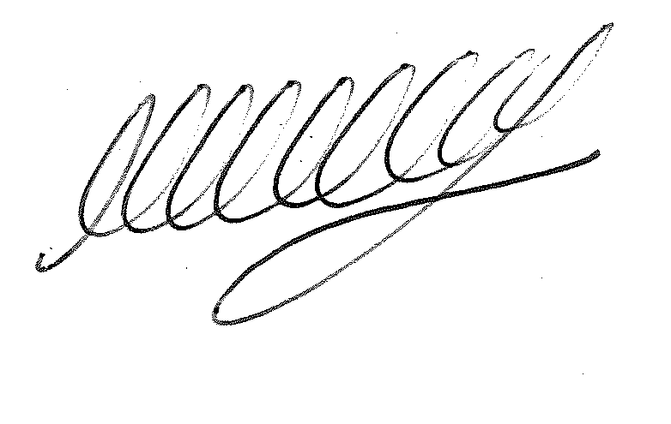

**SIGNED ………………………………………………… DATE: 5th December 2023**

**M WELLS - TOWN CLERK**