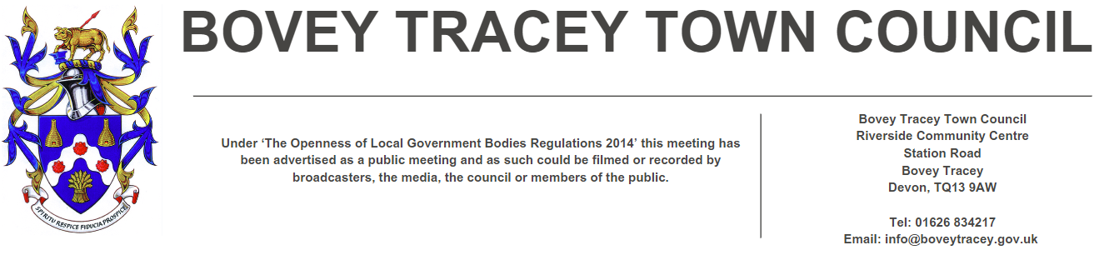

3rd June 2025

**To: Members of the Finance, Resources & General Purposes Committee**

Cllrs Brooke (Ex Officio), Allen, Burton, Fletcher, Kennedy & Oldrieve.

Cc: All other Members of the Council for information**.**

Dear Councillor,

You are hereby summoned to attend a meeting of the **Finance, Resources and General Purposes (FR&GP) Committee** on **Monday 9th June 2025 at 7.00 pm** at the **Riverside Community Centre** for the purpose of transacting the business as set out on the agenda below.

**AGENDA**

**FR&GP.25/40 Election of Chairperson of the Finance, Resources and General Purposes Committee for 2025/26:**

To **elect** a Committee Chairperson for 2025/26.

**FR&GP.25/41 Election of Vice-Chairperson of the Finance, Resources and General Purposes Committee for 2025/26:**

To **elect** a Committee Vice Chairperson for 2025/26.

**FR&GP.25/42 Apologies for absence**

To **receive** and **consider** for acceptance, apologies for inability to attend.

**FR&GP.25/43 Declarations of Interest and Requests for Dispensations**

To **declare** any disclosable pecuniary interests or any other interest which members may have in the following agenda items and **consider** any dispensation requests.

**\*\*Public Participation:**

*We welcome the public to attend meetings and invite comments or questions regarding any of the agenda items. The Committee, at the Chairperson’s discretion, sets aside a short period of time for this at the commencement of the meeting.*

**FR&GP.25/44 Minutes**:

i) To **agree** as a correct record and **approve** the minutes of the meeting of 14th April 2025 *(*[*\*copy enclosed*](https://www.dropbox.com/scl/fi/h3pwwrn2bnaj9hfi3ox3v/09.06.25-Draft-Minutes-of-FR-GP-Committee-Meeting-of-14.04.25.docx?rlkey=i2zccvxslhoef66dlolvxrxxo&dl=0)*).*

ii) To **receive** any update(s) on actions/items from the previous meeting.

**FR&GP.25/45 Standing Item – Climate and Ecology Emergencies:**

To **note** the Council Declaration and to embed the climate and ecology emergency declaration across all Council services, activities, plans and other relevant work, considering the environmental impact of decisions, ensuring a fully integrated approach to mitigating the impact of climate change.

**FR&GP.25/46 Accounts & Financial Statement**:

To **receive** and **approve:**

i) Payment and receipt transactions between 1st April 2025 and 21st May 2025 *(*[*\*copy enclosed*](https://www.dropbox.com/scl/fi/t0efse8mx5opuuaxjmwjm/09.06.25-Payment-and-Receipt-Transactions-01.04.25-21.05.25.pdf?rlkey=pq082e8gldxadzvbo3i4twf77&dl=0)*).*

ii) Bank reconciliation between 1st April 2025 and 21st May 2025 *(*[*\*copy enclosed*](https://www.dropbox.com/scl/fi/92m6u2xg8k1eg7jyz8pdw/09.06.25-Cash-and-Investment-Reconciliation-as-at-21-May-2025.pdf?rlkey=zonprpw9c3yeawpwh2eqfgmer&dl=0)*).*

iii) **note** the balances and borrowing as below:

General Account: £ 33,999.04 (as at 21.05.25)

Income/Precept A/C: £ 202,219.50 (as at 21.05.25)

Capital A/C: £ 32,872.41 (as at 21.05.25)

CIL A/C: £ 115,940.73 (as at 21.05.25)

National Lottery Grant: £ 36,444.16 (as at 21.05.25)

Redwood Bank (Rev) £ 85,000.00 (as at 21.05.25)

Charity Bank Invest (Rev) £ 85,000.00 (as at 21.05.25)

Cambridge & Counties (CiL) £ 130,000.00 (as at 21.05.25)

Nationwide Build Soc (CiL) £ 130,000.00 (as at 21.05.25)

B’hamshire Build Soc (Cap) £ 110,000.00 (as at 21.05.25)

Hampshire Trust Bank (CiL) £ 130,000.00 (as at 21.05.25)

Borrowing

Public Sector Works Loan £ - 366,748.04 (as at 31.03.25)

**FR&GP.25/47 Policy Reviews:**

To **review** and **consider** a recommendation to Full Council to re-adopt the following policy:

- Treasury & Investment Policy ([*\*copy enclosed*](https://www.dropbox.com/scl/fi/w8v75j3n5rowabnkfa78z/09.06.25-Treasury-Investment-Policy-2025-Review.doc?rlkey=wgla1z4nniv0vim5aokl2936d&dl=0))

**FR&GP.25/48 Deferred Item FR&GP.25/36 Grant Request(s):**

To **receive** and **consider** a deferred application for CiL grant funding from:

1. £25,000 – Bovey Tracey Swimming Pool Trust ([*\*copy enclosed*](https://www.dropbox.com/scl/fi/7ia1yo7diuefhtgw9bkgn/09.06.25-CiL-Grant-Application-Bovey-Tracey-Swimming-Pool.pdf?rlkey=bh4jcf1btx0ic3djkaphurts1&dl=0))

**FR&GP.25/49 Capital Programme:**

i) To **consider approving** the template/process for **reviewing and scoring** Capital Projects ([*\*copy enclosed*](https://www.dropbox.com/scl/fi/1n5rvvszonyukqldpuirs/09.06.25-Capital-Expenditure-Programme-Working-DRAFT-for-Scoring-Testing.xlsx?rlkey=7js1stp95pwc6hhn6i0qigxuw&dl=0)).

ii) To **consider reviewing** the Capital Programme and **agree** any resulting actions as appropriate ([*\*copy enclosed*](https://www.dropbox.com/scl/fi/ktoia45hbjzrqq16rvkje/09.06.25-Capital-Expenditure-Programme.xlsx?rlkey=t68mvobhn9oop85467d8436c4&dl=0)).

**FR&GP.25/50 Internal Audit Report – Year End 31st March 2025:**

To **receive** and **consider** the recommendation(s) and subsequent action(s) highlighted within the audit report *(*[*\*copy enclosed*](https://www.dropbox.com/scl/fi/imobhjt23ocilnek6tebq/09.06.25-Copy-of-2024-25-Bovey-Tracey-Town-Council-Year-End-Internal-Audit-Observations.xlsx?rlkey=a48fybif5525z58kh3k0o782j&dl=0)*).*

**FR&GP.25/51 Direct Debits and Standing Orders:**

To **receive** and **approve** alist of Direct Debit/Standing Order payments *(*[*\*copy enclosed*](https://www.dropbox.com/scl/fi/wlvaatvn0qc74awj0spjd/09.06.25-Direct-Debits-Contracts-List_2025-2026.pdf?rlkey=vgdctj10quvzgpgpmtvbj0gks&dl=0)*).*

**FR&GP.25/52** **Community Infrastructure Levy (CiL) Annual Report 2024/25:**

i) To **note** the content of the CiL Annual Financial Report 2024/25 *(*[*\*copy enclosed*](https://www.dropbox.com/scl/fi/ahzmw2ibty94q4n9mtct4/09.06.25-2024-25-CIL-Annual-Report.xlsx?rlkey=2rsdm6gt9lecg8ah4zmuswiwl&dl=0)*)*

ii) To **approve** the publication of the report in accordance with regulation 62A of the Community Infrastructure Levy (CiL) Regulations 2010 (as amended).

**FR&GP.25/53 Public Toilets – Contract Cleaning**

To **consider** the following:

1. **Renewing** the **appointment** of the current Contractor for unlocking, locking and cleaning the public toilets for a further 12-months.
2. **Approving** the proposed contract cleaning cost increases:

2024/252025/26

Station Road Public Toilets £773.38pm plus vat £827.51pm plus vat

Recreation Ground Public Toilets £297.58pm plus vat £318.41pm plus vat

**FR&GP.25/54 Matters brought forward by Councillors:** *(for information only*).

**SIGNED DATE: 3rd June 2025**

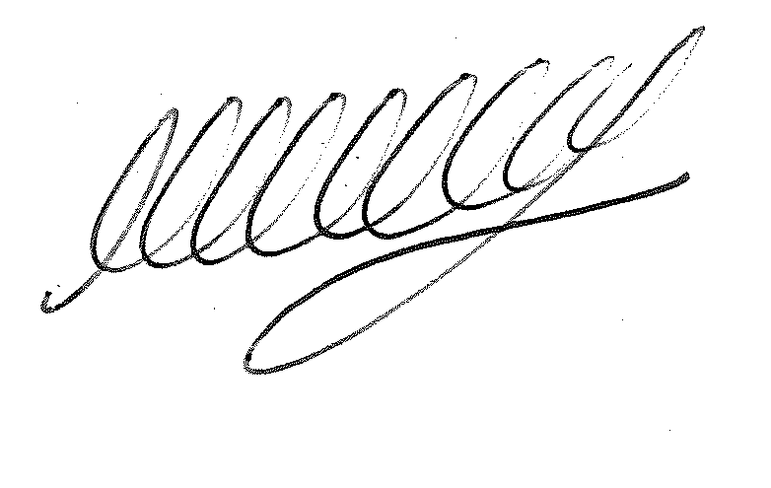

**M WELLS - TOWN CLERK**

***\*Copies of correspondence circulated to Councillors with this agenda, which will be considered at the meeting.***