

26th September 2023

**To Members of the Planning & Environment Committee**

Cllrs Brooke (Ex Officio), U Arnold, Evans, Kelly, Kennedy, Simmons, West.

Cc: All other members of the Council for information.

Dear Councillor,

You are hereby summoned to attend a meeting of the **Planning & Environment Committee** whichwill be held at the **Riverside Community Centre** on **Monday 2nd October 2023** at **6:15pm** for the purpose of transacting the business as set out on the agenda below.

**AGENDA**

**PL.23/102 Apologies for absence**:

To **receive** and **consider** for acceptance, apologies for inability to attend.

**PL.23/103 Declarations of Interest and Requests for Dispensations**

To **declare** any disclosable pecuniary interests or any other interest which members may have in the following agenda items and **consider** any dispensation requests.

**\*\*Public Participation:**

*We welcome the public to attend meetings and invite comments or questions regarding any of the agenda items. The Committee, at the Chair’s discretion, sets aside a period of time for this at the commencement of the meeting.*

**PL.23/104 Minutes:**

i) To **agree** as a correct record and **approve** the minutes of the meeting of 4th September 2023 *(*[*\*copy enclosed*](https://www.dropbox.com/scl/fi/0yho0yxtvrl1bc8791e4o/02.10.23-DRAFT-Planning-and-Environment-Committee-Minutes-of-04.09.23.docx?rlkey=6kkhx8cxii0uziyhnrgm9z7mx&dl=0)*).*

ii) To **receive** any update(s) on actions/items from the previous meeting.

**PL.23/105****Standing Item – Climate and Ecology Emergency:**

To **note** the Council Declaration and to embed the climate and ecology emergency declaration across all Council services, activities, plans and other relevant work, considering the environmental impact of decisions, ensuring a fully integrated approach to mitigating the impact of climate change.

**PL.23/106 Consideration of Planning Applications**:

TDC Applications listed to 25.08.23:

**a) 23/01532/REM** Approval for details for Custom Build Plot 7 pursuant to outline planning permission 17/02118/MAJ (approval sought for appearance, landscaping, layout and scale); Custom Build Plot 7, Land to the North of Indio House, Newton Road, Bovey Tracey (Observations due: 03.10.23).

**b) 23/01538/REM** Approval for details for Custom Build Plot 6 pursuant to outline planning permission 17/02118/MAJ (approval sought for appearance, landscaping, layout and scale); Custom Build Plot 6, Land to the North of Indio House, Newton Road, Bovey Tracey (Observations due: 03.10.23).

**c) 2301491/CLDP** (*To note Application Withdrawn*) Certificate of lawfulness proposed to replace doors for improved access for people with impaired vision/mobility; Church of St Peter, St Paul and St Thomas of Canterbury, East Street, Bovey Tracey (Observations: Not consulted).

DNPA Applications listed to 01.09.23:

**d) 0393/23** Selected replacement windows; Yarner House, Bovey Tracey (Observations due: 03.10.23)

**e) 0397/23** Installation of solar panels; The Barn, Kelly Cottages, Moretonhampstead Road, Lustleigh (Observations due: 03.10.23)

TDC Applications listed to 01.09.23:

**f) 23/01560/HOU** Proposed sun lounge to replace existing conservatory; Strelna, Lowerdown, Bovey Tracey (Observations due: 03.10.23)

DNPA Applications listed to 08.09.23:

None.

TDC Applications listed to 08.09.23:

**g) 23/01489/FUL** Agricultural barn and workshop space; Land at Ngr 282397 78855 Bovey Tracey (Observations due: 03.10.23)

DNPA Applications listed to 15.09.23:

None.

TDC Applications listed to 15.09.23:

**h) 23/01564/HOU** Two storey side extension; 4 St Pauls Close, Bovey Tracey (Observations due: 12.10.23)

DNPA Applications listed to 22.09.23:

None.

TDC Applications listed to 22.09.23:

1. **23/01602/HOU** Single storey side extension and associated works; Lynfield, Brimley Road, Bovey Tracey (Observations due: 13.10.23)

**PL.23/107** **Applications Delegated to the Town Clerk (to note):**

**a) 23/00940/TPO** To cut down and remove the large dying Cherry Tree in the car park; Brimley Court, Brimley Road, Bovey Tracey (Observations: Refer to Arboricultural Officer)

**b) 23/01661/TPO** T1 – Ash. Remove major deadwood over garden areas approximately 25mm and greater; 21 Rendells Meadow, Bovey Tracey (Observations: Refer to Arboricultural Officer)

**c) 23/01716/CAN** Removal of Acacia Dealbata tree; 91 Mary Street, Bovey Tracey (Observations: Refer to Arboricultural Officer)

**d) 23/01724/TPO** To dismantle two smaller Lawson Cypress down to ground level and the dead stem behind using arb approved techniques; Indio House, Newton Road, Bovey Tracey (Observations: Refer to Arboricultural Officer)

**PL.23/108** **Planning Decisions**:

1. **Approvals:**   
   TDC:

**i) 23/00532/HOU** Demolition of existing extensions and replacement two storey side and rear single storey extension; Oldfield House, Lowerdown, Bovey Tracey (Observations: No objection)

**ii) 23/01546/TPO** T1 Quercus robur, Fell; 1 Brow Hill, Heathfield (Observations: Referred to Arboricultural Officer).

**iii) 23/01562/TPO** T1 Oak, fell. T2 Beech, fell. T3 Beech Cluster, fell. T4 Scotts Pine, fell. T5 small whip cluster, fell. T6 Scotts Pine, fell. T7 Scotts Pine, fell. T8 Beech Sapling, fell. T9 Scotts Pine, fell. T10 Silver Birch, fell. T11 – 13 Small cluster saplings, fell. T14 Beech, fell. T15 Beech, fell. T16 Beech, fell. T17 Beech, limb removal. T18 Beech crown raise of 5 lower limbs protruding over road. T19 Beech sapling, fell. T20 Beech crown raise removing 5 lower limbs protruding towards road. T21 Scots Pine, fell. T22 Beech sapling cluster, fell. T23 Beech, prune lowest branch to collar on main stem. T24 Beech prune to collar on main stem. T25 Beech, prune to collar on main stem. T26, Beech sapling, fell. T27 Beech, prune back 3 metres. T28 Beech, prune to collar. T29, Beech, fell. T30 Beech, prune to collar on main stem. T31 Holly, remove: Powerpark 38, Old Newton Road, Bovey Tracey (Observations: Referred to Arboricultural Officer).

**iv) 23/00984/FUL** Conversion of existing residential building used for purposes ancillary to Heatherside to use as a dwelling; 18 Pottery Road, Bovey Tracey (Observations: No objection)

DNPA:

**v) 0319/23** Repairs to south east and north east ground floor windows; Yarner House, Bovey Tracey (Observations: No objection)

**vi) 23/0056** (Split decision 75% approved, with tree removal refused, subject to allowing lesser crown reduction works)Oak T3 (T1 in report), Crown reduce by approx.. 2m. Sycamore T4 (T2 in report) Fell (Observations: Referred to Arboricultural Officer).

**vii) 0314/23** Alterations and extensions; 1 Ullacombe Cottages, Haytor Road, Bovey Tracey (Observations: No objection)

**b)** **Refusals:**   
 TDC:

None.

DNPA:

None.

**PL.23/109 General Planning Matters brought forward by Councillors**: *(For information only)*

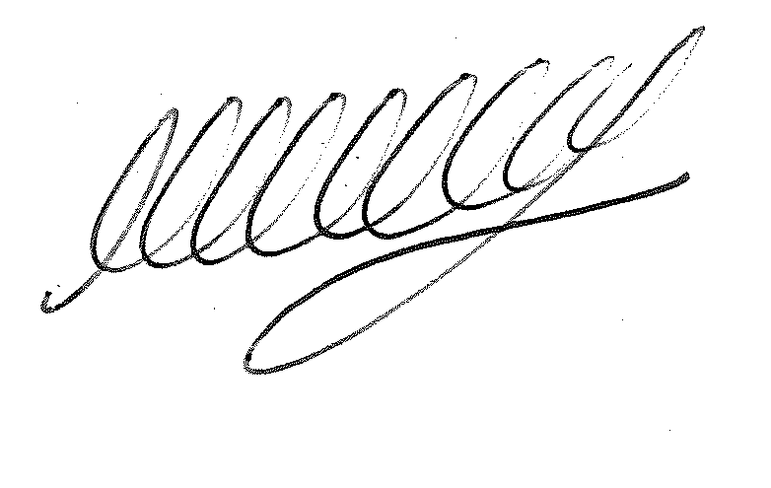

**SIGNED ………………………………………………… DATE: 26th September 2023**

**M WELLS - TOWN CLERK**